(Approx. 805 words)

Enliven Documents with Themes
By Nancy DeMarte, 1st Vice President, Sarasota Technology User Group, FL
October 2015 issue, Sarasota Technology Monitor
www.thestug.org
ndemarte (at) Verizon.net

If you often find yourself creating documents in Word or spreadsheets in Excel, you probably use the same font and layouts most of the time. You would be surprised how lively and stylish these files could be if you applied a theme to them. Themes in Word and Excel are Style sets that coordinate the color scheme, fonts, line and paragraph spacing, and effects. The Themes gallery is located on the Design tab in Word and the Page Layout tab in Excel. I will use Word 2013 as an example of how you can apply and customize themes in your documents.

Choose and Apply a Theme
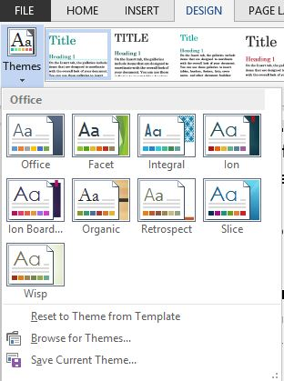
The default theme in Word and other Office programs is appropriately named “Office,” but you can apply a different theme to a document either during its creation or after. For example, I opened a blank document, clicked the Design tab, then Themes (left side of the ribbon), to open the Themes gallery. I chose the “Ion” theme, although I could have browsed for more online. A group of Styles that coordinate with this theme appeared in the ribbon. I chose a colorful one called “Lines (Simple)” and began to create my document.

First, I typed the title and highlighted it to display the Font toolbox just below it. I clicked Styles (bottom right) and selected the Title style, which changed my title to a maroon color and 40-point text. The title seemed too large, so I reduced the font size to 24 points. All these font changes can also be made on the Home tab – Font group.

Next, I typed an introduction and my first heading, highlighted it, chose Styles from the font toolbox again, and picked Heading 1. It also was a maroon color, 18 points, and included a line below it. I changed the size to 14 points to be consistent with the new title size.

Then I typed the body of the document. After I had typed the first line of text, I clicked inside a word and learned that the theme’s body text was Century Gothic, 10.5 point, Normal style.
Just for fun, I added a couple of shapes from the Shapes gallery (Insert tab – Shapes) Sure enough; they too were a maroon color, keeping with the theme.

Customize and Save a Theme
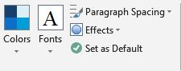
Next, it was time to experiment with changing a few of the elements of the theme. With my document open, I clicked the Design tab and then Colors, which revealed a menu of color schemes, each which included several coordinated colors. I clicked “Blue” and immediately found that all my maroon-colored features had turned a medium blue. Then I clicked Fonts and chose “Times New Roman – Arial.” The title and all the headings became the Times New Roman font, while the body text changed to Arial.
Theme Customization Tools

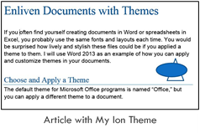
With my cursor still in the document, I clicked Paragraph Spacing, which displayed a list of preset distances between lines and paragraphs. Hovering my mouse over Default showed my theme’s spacing. I hovered my mouse over each of the choices to preview how it would affect my document. I decided on the Open spacing set, which added a little more space between lines and paragraphs. Because I had only a few objects or shapes in this document, I did not change the Effects, but clicking that icon showed me what changes were possible.
Now it was time to save this custom theme. I clicked the Design tab, Themes button, and selected “Save Current Theme” at the bottom of the gallery. I typed a name, “My Ion,” in the dialog box and clicked Save. This put my modified theme into the Custom area above the Theme gallery. The theme was also stored as MyIon.thmx in a special Document Themes folder.

Two Important Cautions
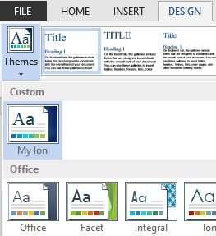
1. Don’t confuse saving a theme with setting it as the default. If you save your custom themes, you have the choice of when to use them. If you set a custom theme as the default, it will affect all future documents and may give you some unexpected results.
My Custom Theme in Word
2. The Office theme is different from the rest in the theme gallery in that it affects all of the Office applications. If you make a change to the Office theme, such as changing the background from white to gray, and set it as the default, it will affect all programs in your Microsoft account, including those on other computers. However, saving your own custom themes in Word or Excel can be a handy way to give your documents some style and avoid re-creating a favorite theme each time you need it.

